Scanning Near-field Optical Microscopy (SNOM/NSOM)
NSOM/SNOM is a microscopic technique used for nanostructure investigation that breaks the far field resolution limit by exploiting the properties of evanescent waves.
Let us first see what evanescent waves are?

Evanescent Waves
In optics and acoustics, evanescent waves are formed when waves travelling in a medium undergo total internal reflection at its boundary because they strike it at an angle greater than the so-called critical angle.

Properties of Evanescent Waves
- Intensity that exhibits exponential decay with distance from the boundary.
- Electric and Magnetic fields cannot be discontinuous at a boundary.
- These are formed at the boundary between two "media" with different properties in respect of wave motion.

Basic principles of SNOM:

Abbe’s Theory of Image Formation:
The minimum resolution (d) for the optical component are limited by its aperture size, and expressed by the Rayleigh criterion
d=0.61*λ/NA
Here,
λ is the wavelength in vacuum
NA is the Numerical Aperature for the optical component (usually 1.3–1.4 for modern objectives).

(In optics, the numerical aperture (NA) of an optical system is a dimensionless number that characterizes the range of angles over which the system can accept or emit light.)
Thus, the resolution limit is usually around λ₀/2 for conventional optical microscopy.
NSOM makes use of evanescent or non propagating fields that exist only near the surface of the object. These fields carry the high frequency spatial information about the object and have intensities that drop off exponentially with distance from the object. Because of this, the detector must be placed very close to the sample in the near field zone, typically a few nanometers.
As a result, near field microscopy remains primarily a surface inspection technique.

Instrumentation and standard setup

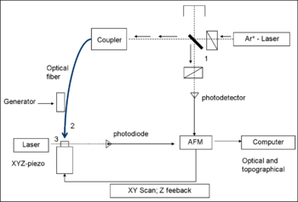

Fig: Instrumentation and standard setup

The primary components of an NSOM setup are the light source, feedback mechanism, the scanning tip, the detector and the piezoelectric sample stage.
The light source is usually a laser focused into an optical fiber through a polarizer, a beam splitter and a coupler. The polarizer and the beam splitter would serve to remove stray light from the returning reflected light. The scanning tip, depending upon the operation mode, is usually a pulled or stretched optical fiber coated with metal except at the tip or just a standard AFM cantilever with a hole in the center of the pyramidal tip. Standard optical detectors, such as avalanche photodiode, photomultiplier tube (PMT) or CCD, can be used. Highly specialized NSOM techniques, Raman NSOM for example, have much more stringent detector requirements.

How to Conduct an Experiment Using Scanning Near-Field Optical Microscopy (SNOM or NSOM)
In order to make an NSOM/SNOM experiment, a point light source must be brought near the surface that will be imaged (within nanometers). The point light source must then be scanned over the surface, without touching it, and the optical signal from the surface must be collected and detected. There are a few different ways to obtain a point light source: One can use pulled or etched optical fibers (tapered optical fibers) that are coated with a metal except for at an aperture at the fiber's tip. The light is coupled into the fiber and is then emitted at the sub-wavelength (50 nm or larger) aperture of the fiber. Or, one can use a standard AFM cantilever with a hole in the center of the pyramidal tip. A laser is focused onto this hole, which is of sub-wavelength dimensions.
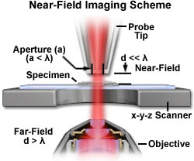
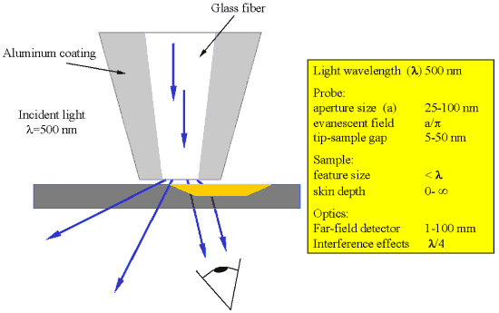
Contrast that we get in the final image produced by SNOM can be used to analyse:
- Changes in the index of refraction
- Changes in the reflectivity
- Changes in the transparency
- Changes in polarization
- Stress at certain points of the sample that changes its optical properties
- Magnetic properties, which can change the optical properties
- Fluorescent molecules
- Molecules excited through a Raman shift or other effects
- Changes in the material

Feedback Mechanisms:

Shear Force Feedback and Normal Force Feedback
The resolution of an NSOM/SNOM measurement is defined by the size of the point light source used (typically 50-100 nm). The distance between the point light source and the sample surface is usually controlled through a feedback mechanism that is unrelated to the NSOM/SNOM signal. Currently, most instruments use one of the following two types of feedback: shear force or normal force. In the shear force feedback, or tuning fork feedback, the straight tip is mounted to a tuning fork, which is then oscillated at its resonance frequency. The amplitude of this oscillation is strongly dependent on the tip-surface distance, and it can be effectively used as a feedback signal.

Different Operating Methods for Scanning Near-Field Optical Microscopy (SNOM)
Scanning near-field optical microscopy can be performed in many different ways of operation. Most common today is the use of aperture probes for transmission microscopy, either in illumination (a) or in collection (b). However, many samples or substrates are opaque, so that working in reflection is necessary (c). The reflected light can be collected by optics close to the tip, or by the fiber probe itself, in which case often uncoated fiber tips are used.
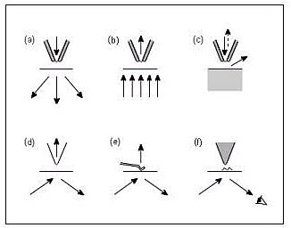

The Advantages of SNOM:
- High resolution (upto 25 nm).
- Analysis of various properties made possible through contrast.
- No special sample preparation needed.Can be used for different kind of samples (conductive, non-conductive & transparent).

The Limitations of SNOM:
- Very low working distance and extremely shallow depth of field.
- Limited to study of surfaces.
- Not conducive for studying soft materials, especially under shear force mode.
- Long scan times for large sample areas or high resolution imaging.

Applications of SNOM
- Ideally suited to quickly and effortlessly image the optical properties of a sample with resolution below the diffraction limit.
- In Nanotechnology research.
- In Nano-Photonics and Nano-Optics.
- Life Science and materials research - optical detection of the most miniscule surface
- Single molecule detection is easily achievable
- Dynamic properties can also be studied at a sub-wavelength scale

Now, we will explain three particular application areas of SNOM.

1. Application in Nanotechnology
Today everyone is talking about Carbon Nanotubes, because the fundamental properties of single-walled carbon nanotubes (SWNTs) show great promise for future applications in electronics, sensing, and medicine. SWNTs are tubular sp²-hybridized carbon structures with typical diameters of 1nm with lengths ranging from a few nanometers to several microns.
SWNTs display of wide-range of electrical character, varying from metallic to semiconducting, depending on the arrangement of the carbon atoms along the tube axis. In addition, SWNTs display high thermal stability, structural rigidity, and chemical inertness due to the robust nature of carbon-carbon bonds.
Now, it might be the case that we have explored only a few properties of CNTs. Rest of them may not have been found. Understanding the optical properties of specific types of SWNTs is important from both a fundamental standpoint in understanding the unique properties of CNTs.
NSOM has been used to image and perform Raman spectroscopy along the length of an isolated SWNT with ~25 nm spatial resolution. The near-field Raman image was collected by raster scanning the probe across the sample and detecting the scattered Raman signal.
Raman signal were observed for different locations along the length of the SWNT.

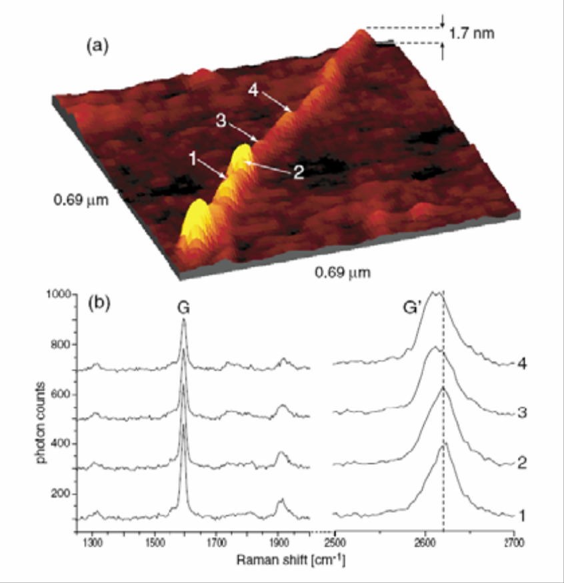
In above figure (a) shows an AFM topographic image of a SWNT recorded simultaneously the Raman data. Figure (b) shows the data for the labeled points 1-4 in Figure peaks labeled G and G’ are typical Raman peaks observed for SWNTs.
In the above figure we can see that AFM & SNOM were used to focus on CNT’s. But SNOM has shown better resolution to study CNT’s. From this we can see that SNOM is yet to play a very important role in Nano Research.

2. Dielectric Grating
Phase contrast is obtained when imaging samples induce differences in the optical path. A typical example for such a sample is a dielectric grating. An AFM topograph of such a grating is shown in Fig. (a), accompanied by a height profile in (b). The grating structure has a period of 383 nm and a step height of 8 nm which was etched into a thin glass substrate. Figure(c) shows a very high resolution constant height mode optical image recorded at a gap width below 1nm. Figures (d) and (e) show constant height mode optical images recorded gap of a few nm and '100 nm, respectively. This series of images clearly evidences the strong dependence of the resolution on the gap width.

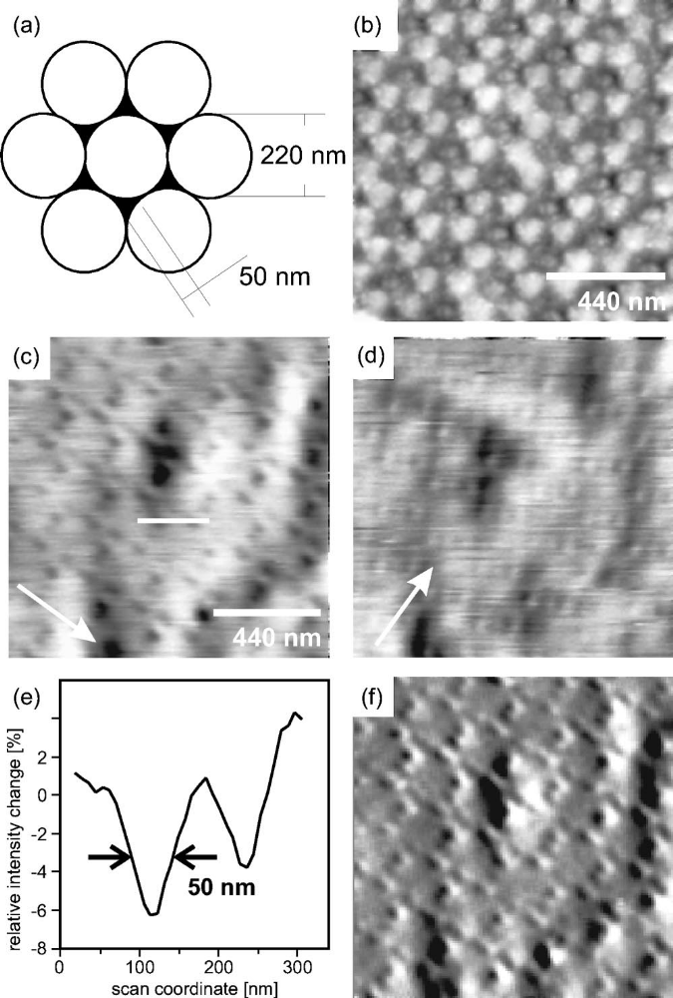

3. Pulsed Laser Ablation through SNOM Tips
Optical probes produced by tube etching are stable enough to withstand several tenths of mJ of pulsed laser radiation coupled into them. The intensity at the aperture can be in excess of 108 W/cm2, which is enough to cause ablation of a sample close to the tip. Several mechanisms are possible for laser-induced ablation through SNOM tips. The photochemical model assumes that the energy is deposited in the sample via optical absorption, and ablation follows as a consequence of chemical bond breaking. Similarly, in a photo thermal scenario, the absorbed optical energy would be converted into heat, causing ablation from the locally heated spot. Third, a ballistic mechanism is conceivable, where material from the tip is sputtered onto the sample, causing ablation of material from its surface. A ballistic mechanism was the most likely explanation for an experiment carried out on an anthracene sample using a completely metallized SNOM tip. In the absence of any photons reaching the sample, sputtering by either metal atoms from the tip, or by material adsorbed on its surface, was believed to be the reason for the ablation process. Fourth, one also has to take into account transient thermal expansion as a possible mechanism for the creation of surface indentations, but it is likely to be negligible.
We now discuss an experiment that gave very clear results about the ablation mechanism from a rhodamine B film. This sample was irradiated either on resonance (532 nm) or off resonance (650 nm) with respect to its optical absorption maximum Fig. (a). SNOM tips with apertures of, 100 nm diameter were used. No significant drop in optical output of the SNOM tip was measured for similar input energies at 400 and 650 nm input wavelength, although some decrease is expected due to the increasing difference between wavelength and aperture size. Figures (b) and (c) show shear force topographic images recorded after several laser pulses had been fired onto the sample. No ablation was observed for the off-resonance wavelength [Fig (b), l5650nm, 2.1 mJ pulse energy]. In contrast, well defined, '70 nm diameter (FWHM), 5 nm deep holes were created by a wavelength that is strongly absorbed by the sample [Fig (c), l5532 nm, 1.4 mJ pulse energy]. This clearly points to an optical ablation mechanism, either photochemical or photo thermal. Energy transfer by absorption of photons appears to be more efficient than by a ballistic process. The photon energy used here is not sufficient for inducing chemical bond dissociation in the rhodamine film, in contrast to ablation processes with ultraviolet laser radiation, where a photochemical ablation mechanism is often used to rationalize the observed phenomena. We therefore suggest that a photo thermal mechanism is responsible for the ablation of the rhodamine film: we believe that the absorbed photon energy is converted to vibrational excitation, causing a rapid temperature increase that leads to thermal desorption of the molecules. Another interesting observation in Fig (c) is that the ablated material is re-deposited on the sample surface close to the ablation crater. The distribution of re-deposited material was not symmetric in this experiment, but was always to the left side of the crater, independent of the scan direction. In other SNOM ablation experiments, the distribution was more symmetric. The origin of the directionality appears to be the tip itself: frequently, the apex of an SNOM tip exhibits some uncontrolled asymmetry, causing the ablated material to be blown off in a specific direction. This has interesting applications for the analytical nano sampling of material surfaces.
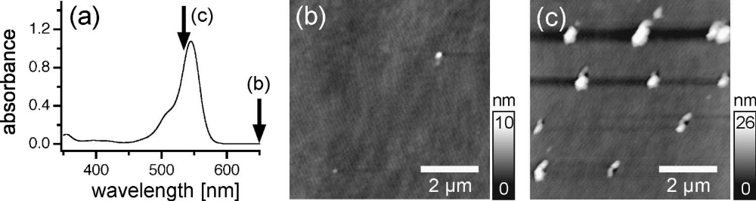
FIG. Near-field optical ablation: (a) Absorption spectrum of rhodamine B at a concentration of 1025 M in methanol solution. Arrows indicate the wavelengths used for the ablation experiments before recording the images on the right. (b),(c) Topography of a rhodamine B film after coupling 2.1 mJ into the SNOM tip at l5650 nm (b), and after coupling 1.4 mJ into the SNOM tip at l5532 nm (c), a wavelength near the maximum absorption of rhodamine B. The total topographic contrast in the z direction is 10 nm (b), and 26 nm (c), respectively.

