SCANNING TUNNELING MICROSCOPE
Brief history:

Heinrich Rohrer and Gerd K. Binnig, scientists at IBM's Zurich Research Laboratory in Switzerland, are awarded the 1986 Nobel Prize in physics for their work in scanning tunnelling microscopy. Binnig and Rohrer were recognized for developing the powerful Scanning Tunnelling Microscopy technique. They shared the award with German scientist Ernst Ruska, designer of the first Electron Microscope. STM can form an image of individual atoms on a metal, semiconductor or other conductive sample surface by scanning the tip of a needle over the surface at a height of only a few atomic diameters, so that tunnel current occurs between the tip and the sample.
Purpose:
A scanning tunnelling microscope is used to demonstrate the principle of quantum mechanical tunnelling between the microscope tip and the surface of a conducting sample.
Components:
1. Scanning tip
2. Piezoelectric controlled height and x, y scanner
3. Coarse sample-to-tip control,
4. Vibration isolation system, and
5. Computer (Data processing and display unit)

Schematic diagram:
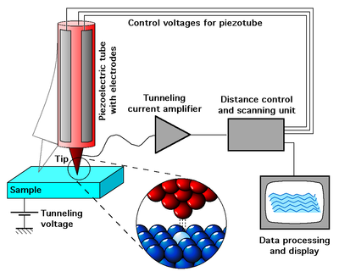

Working:
Scanning tunneling microscope scans the electrons at fixed distance. First, a voltage bias is applied and the conducting tip is placed closer to the sample to be examined. The tip is also known as stylus, stylus is extremely sharp and usually made up of a finest diamond, which is switched off when the tip and sample are sufficiently close.
When a conducting edge or tip is brought near the surface to be tested, a specific voltage variation is applied which allows electrons to pass through the tunnel in the vaccum.In the result, tunneling current is obtained which is the function of accurate tip position. Information is gathered by monitoring the current according to the tip position which scans across the surface, and this information is usually displayed in form of image.
The stylus is moved in the upward direction and then lowered in order to keep the each signal undistorted .This allows it to follow even the smallest data of the surface it is scanning. Storing the vertical movement of the stylus makes it possible to observe the structure of the surface atomically in organized manner. A profile of the scanned surface is created, and with the help of this profile contouring map is generated from the computer system attached to the microscope. The STM works best with conductors. But it can also work with the organic molecules all required is to fix organic molecules on a surface and study their structures. This technique has been used in the study of DNA molecules.
Modes of operation:

1. Constant Current Mode:
By using a feedback loop the tip is vertically adjusted in such a way that the current always stays constant. As the current is proportional to the local density of states, the tip follows a contour of a constant density of states during scanning. A kind of a topographic image of the surface is generated by recording the vertical position of the tip.

2. Constant Height Mode:
In this mode the vertical position of the tip is not changed, equivalent to a slow or disabled feedback. The current as a function of lateral position represents the surface image. This mode is only appropriate for atomically flat surfaces as otherwise a tip crash would be inevitable. One of its advantages is that it can be used at high scanning frequencies (up to 10 kHz). In comparison, the scanning frequency in the constant current mode is about 1 image per second or even per several minutes.

3. Barrier Height Imaging:
The Local Barrier Height (LBH) spectroscopy provides information about the spatial distribution of the microscopic work function of the surface, as described below.
The tunneling current I_{T} in STM exponentially decays with the tip-sample separation z as
I_{T} ~ exp(-2kz),
where the decay constant is given by
2k = 2(2mU/h2)^{1/2}.
In the LBH imaging, we measure the sensitivity of tunnel current to the tip-sample separation at each pixel of an STM image. The LBH obtained in this method is the so-called apparent barrier height U defined by
U= 0,95(1/I_{T} )2 (dI_{T} /dz)2
This U is customarily compared to an average work function U_{av} = (U_{s} + U_{t} )/2, where U_{t} and U_{s} are the tip and sample work functions, respectively. In many cases, experimental U does not precisely agree with U_{av} but tends to be slightly smaller. Nevertheless, it is known that U is closely related to the local surface potential (local work function) and is a good measure of it.
The LBH image is obtained by measuring point by point the logarithmic change in the tunneling current with respect to the change in the gap separation, that is, the slope of log I vs. z. In the LBH measurement, the tip-sample distance is modulated sinusoidally by an additional AC voltage applied to the feedback signal for the z-axis piezodevice attached to the tip. The modulation period is chosen to be much shorter than the time constant of the feedback loop in the STM.

4. Density of States Imaging:
As long as measured in STM current is determined by the tunneling processes through tip-sample surface gap its value depends not only on the barrier height but on the electron density of states also. Accordingly obtained in STM images are not simply images of sample surface relief (topography), these images can be hardly affected by the density of electronic states distribution over the sample surface. Good example of Local Density of States (LDOS) influence on the STM image is well-known image of highly oriented pyrolitic graphite (HOPG) atomic lattice. Only half atoms are visible in STM. Similar case is image of GaAs atomic lattice.
LDOS determining can also help to distinguish chemical nature of the surface atoms. LDOS acquisition is provided simultaneously with the STM images obtaining. During scanning the Bias Voltage is modulated on the value dU, the modulation period is chosen to be much shorter than the time constant of the feedback loop in the STM.
Suitable modulation of tunnel current dI is measured, divided by dU and presented as LDOS image. On Example the topography and LDOS image of HOPG sample are presented.
Example:
With a large band gap, a high break down field and a high saturation drift velocity of the conducting electrons SiC is an interesting material for semiconductor technology. Thus its surface structure and the surface electronic properties are of a great importance for material growth and device fabrication. SiC surface show a variety of surface reconstructions. One of those structures is the (3x3) phase on SiC(0001) whose actual atomic geometry has long been unresolved.
STM experiments provided some insight in the structure:
1. There is a single protrusion per unit cell
2. The corrugation is independent of the tunneling voltage
3. Large corner holes cannot be seen
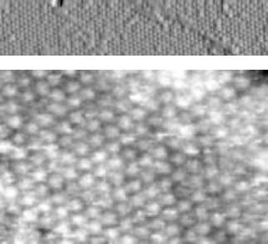
3x3 4H SiC (0001)
Combining this with results from electron spectroscopy and low-energy electron diffraction (LEED) The surface geometry could be determined in detail.
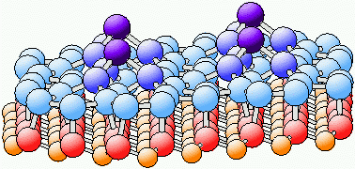

The properties of the SiC(0001) 3x3 structure are:
- a compact, planar Si adlayer with sp² hybridisation within the layer,
- a twist rotation of the Si-trimer covering the adlayer and its surrounding atoms within the adlayer,
- single dangling bond per (3x3) unit cell located at the adatom ontop of the trimer,
- ideal Si-Si bond lengths (2.31-2.39Å) and fourfold coordination of all other atoms.
Some issues regarding STM:
- STM could be a challenging technique, as it needs very clean and plain and stable surfaces, extra sharp tips, high vibration control, and efficient and integrated electronic devices. These all specifications make STM expensive.
- The resolution of the image scanned by STM is limited because radius of curvature is fixed and scanning stylus tip does not support the modification in the resolution.
- If scanning tip has two tips than there is a chance of occurrence of artifacts instead of single atom display.
- Because of huge sensitivity of tunnel current, proper vibration and isolation is required for obtaining best results from the STM.
- At first, Binnig and Rohrer magnetic levitation was used to keep the scanning tunneling microscope free from extra vibrations and now mechanical or gaseous spring systems are usually used for controlling vibrations. Additional mechanisms for reducing current are also required sometime to proper implement the scan.

