ME-228 Materials and Structure Property Correlations

***Electron Energy Loss Spectroscopy (EELS)***

**Submitted by,**

**Anbukkarasi.R. (05-07-00-10-12-12-1-09843)**

**Isha Gupta. (05-07-00-10-41-12-1-09353)**

**Ramya teja E. (05-07-00-10-41-12-1-09199)**

**Electron energy-loss spectroscopy**

**1. principle:**

Electron energy-loss spectroscopy (EELS) involves measurement of the energy distribution of electrons that have interacted with a specimen and lost energy due to inelastic scattering. In an energy analyzer the electrons are spatially separated by their different speed, and a spectrum is recorded by means of a photo diode array or a CCD.

Each type of interaction between the electron beam and the specimen produces a *characteristic* change in the energy and angular distribution of scattered electrons. The energy loss process is the *primary* interaction event. All other sources of analytical information ( i.e. X-rays, Auger electrons, etc.) are *secondary* products of the initial inelastic event. Thus, EELS has the highest potential yield of information/inelastic event.

An EELS spectrum contains features that result from the excitation of phonons, plasmons, valence electrons and inner-shell electrons in the sample, and is therefore sensitive to chemical composition, electronic structure and coordination. The spectrum contains information about the chemical composition, the optical properties and the density of states (DOS).

Chemical analysis down to the nanometer scale is a standard feature of Electron Energy Loss Spectrometry (EELS). The strong points of EELS are the high spatial resolution of < 1 nm, the low detection limit of a few atoms.

When electron beam is incident into specimen, a part of the electrons is inelastically scattered and loses a part of the energy. Elemental composition and atomic bonding state can be determined by analyzing the energy with the spectroscope attached under the electron microscope (Electron Energy Loss Spectroscopy). Because the analyzing region can be selected from a part of the enlarged electron microscopic image, one can analyze very small region. Moreover, by selecting electrons with a specific loss energy by a slit so as to image them, element distribution in specimen can be visualized (Elemental Mapping).

**1.2. eels Vs XAS:**

For comparison, x-ray absorption spectroscopy (XAS) currently has a lateral resolution of around 30 nm if carried out using synchrotron radiation focused by a zone plate. Owing to the weaker interaction of photons with matter, XAS uses a thicker specimen, which is sometimes an advantage since it allows easier specimen preparation. Also, XAS can examine a specimen surrounded by air or water vapour, whereas the TEM usually places the specimen in a high vacuum.

**2. Instrumentation:**

TEM-EELS instrumentation is based on the magnetic prism, in which a uniform magnetic ﬁeld B (of the order of 0.01 T) is generated by an electromagnet with carefully shaped pole pieces. It is shown in Fig 2.

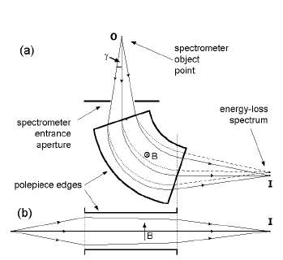

Fig.1. Dispersive and focusing properties of a magnetic prism (a) in a plane perpendicular to the magnetic ﬁeld and (b) parallel to the ﬁeld. Solid lines represent zero-loss electrons (E = 0); dashed lines represent those that have lost energy during transmission through the specimen.

Within this ﬁeld, electrons follow circular paths of radius R and are deﬂected through an angle of typically 90◦. The sideways force on an electron is,

F = Bev = mv 2 /R

Where, e electron speed

v charge

m relativistic mass,

This is giving a bend radius that depends on speed and therefore on electron energy,

R = (m/e). (1/B). v

While this behavior resembles the bending and dispersion of a beam of white light by a glass prism, the electron prism also has a focusing action. Electrons that stray from the central trajectory (the optic axis) in a direction perpendicular to the ﬁeld (ﬁg. 1a) experience an increase or decrease in their path length within the ﬁeld, giving rise to a greater or lesser deﬂection angle. If the entrance beam originates from a point object, electrons of a given energy are returned to a single image point. The existence of different electron energies then results in a focused spectrum in a plane passing through that point.

In addition, the fringing ﬁeld at the pole piece edges focuses electrons that deviate in a direction y, parallel to the magnetic ﬁeld (ﬁg.1b). By adjusting the angles of the pole piece edges, the focusing power in these two perpendicular directions can be made equal (double-focusing condition), giving a spectrum of small width in the direction of the applied magnetic ﬁeld. As a result of second-order aberrations, the focusing is imperfect but these aberrations can be corrected by curving the pole piece edges, allowing an energy resolution better than 1 eV for an entrance angle of upto several milli radians (of the order of 0.3◦ ).

**2.1. TYPE OF SYSTEM:**

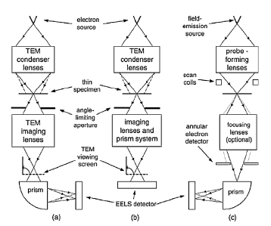The simplest form of energy-loss system consists of a conventional TEM ﬁtted with a magnetic prism below its image-viewing chamber (Fig.2a). By tilting the TEM screen to a vertical position, electrons are allowed to enter the spectrometer, where they are dispersed according to their kinetic energy, which their incident energy E0 minus any energy loss E is occurring in the specimen.

Fig.2. Three procedures for TEM-based energy-loss spectroscopy: (a) conventional TEM with a magnetic-prism spectrometer below the viewing screen, (b) TEM incorporating an in-column imaging ﬁlter and (c) scanning-transmission (STEM)

system.

The spectrometer object point is an electron-beam crossover produced just below the bore of the ﬁnal (projector) TEM lens. A spectrometer entrance aperture, typically variable from 1 to 5 mm in diameter, limits the range of entrance angles and ensures adequate energy resolution. This kind of system requires little or no modiﬁcation of the TEM, which operates according to its original design and speciﬁcation.

An alternative strategy is to incorporate a spectrometer into the TEM imaging column (Fig 2b). For image stability, it is important to preserve a vertical TEM column, so there are usually four magnetic prisms that bend the beam into the shape of a Greek letter, hence the name ‘omega ﬁlter’. An energy-loss spectrum is produced just below the ﬁlter and subsequent TEM lenses project it onto the viewing screen or onto an electronic detector, usually employing a CCD camera. Alternatively, these lenses may focus a plane (within the spectrometer) that contains an image of the specimen, utilizing the imaging properties of a magnetic prism. A narrow slit inserted at the spectrum plane can remove all electrons except those within a small energy window, resulting in an energy-ﬁltered (EFTEM) image on the TEM screen or the CCD camera.

A third type of system (Fig.2c) is based on the scanning-transmission electron microscope (STEM), in which a ﬁeld-emission source and strong electromagnetic lenses are used to form a small probe that can be raster-scanned across the specimen. A dark-ﬁeld image, representing transmitted electrons scattered through relatively large angles, is formed by feeding the signal from a ring-shaped (annular) detector to a display device scanned in synchronism with the probe scan. Electrons scattered through smaller angles enter a single-prism spectrometer, which produces an energy-loss spectrum for a given position of the probe on the specimen. Inserting a slit in the spectrum plane then gives an energy-ﬁltered image, obtained this time in serial mode.

**2.2. RESOLUTION:**

The energy resolution of an energy-loss spectrum is determined by several factors, including aberrations of the electron spectrometer. By curving the pole pieces of the magnetic prism and by using weak multi pole lenses for ﬁne tuning, these aberrations can be almost eliminated.

1. The energy resolution is then determined by the width of the energy distribution provided by the electron source, seen as the width of the zero-loss peak.

* Thermionic sources, such as the tungsten ﬁlament or heated LaB6 source used in many electron microscopes, provide an energy width between 1 and 2 eV.
* A Schottky source (heated Zr-coated W tip) gives a width of about 0.7 eV. A CFEG source (ﬁeld-emission from a cold tungsten tip) gives typically 0.5 eV, although a fast readout of the spectrum combined with software re-alignment can reduce this width to below 0.3 eV.

2. Further improvement in energy resolution is possible by inserting an electron monochromator after the electron source. The monochromator is an energy ﬁlter tuned to a narrow energy band at the centre of the emitted-energy distribution. Although either magnetic-prism or electrostatic-prism designs are possible, a popular choice is the Wien ﬁlter, which uses both electric and magnetic ﬁelds and results in an energy spread of about 0.2 eV.

**3. THE PHYSICS OF EELS:**

When electrons pass through a specimen, they are scattered by interaction with atoms of the solid. This interaction (or collision) involves electrostatic (Coulomb) forces, arising from the fact that the incident electron and the components of an atom (nucleus and atomic electrons) are all charged particles. It can be divided into elastic and inelastic, depending on whether or not the incident electron responds to the ﬁeld of the nucleus or to its surrounding electrons.

**3.1. Elastic scattering:**

Elastic scattering involves the interaction of an incident electron with an atomic nucleus. Because the nuclear mass greatly exceeds the rest mass of an electron (by a factor 1823Awhere A = atomic weight or mass number), the energy exchange is small and usually un measurable in a TEM-EELS system.

**3.2. Inelastic scattering:**

Coulomb interaction between the incident electron and atomic electrons gives rise to inelastic scattering. Similarity in mass between the projectile (incident electron) and the target (atomic electron) allows the energy exchange (loss) to be appreciable; typically a few electron volts up to hundreds of electron volts.

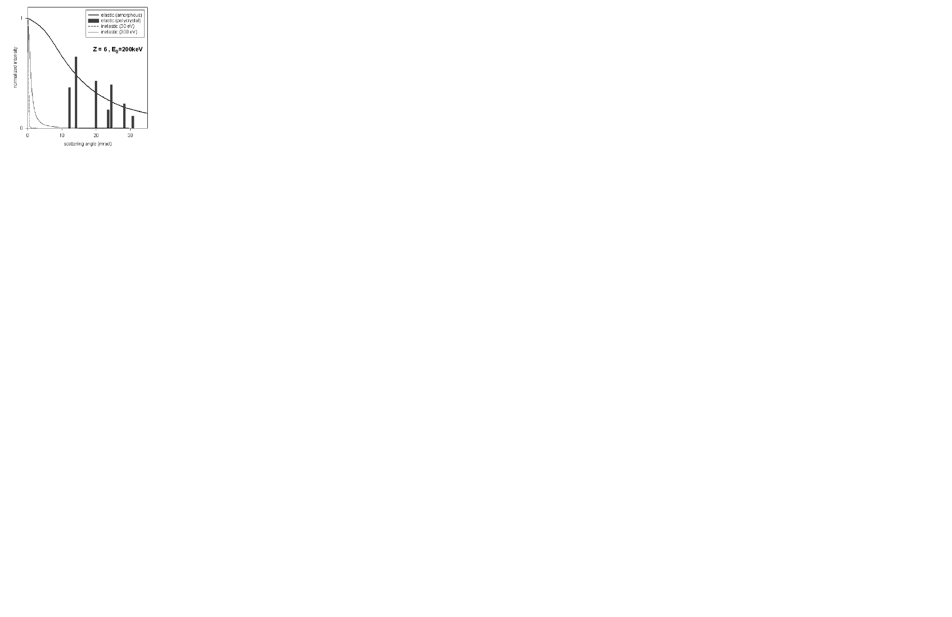

Fig.3. Curves show the angular distribution of elastic and inelastic scattering, calculated for 200 keV electrons in amorphous carbon. Vertical bars represent the relative intensities of the elastic Bragg beams in crystalline diamond when the crystal axes are parallel to the incident beam.

**3.3. Plasmon excitation:**

A prominent form of inelastic scattering in solids involves *plasmons* excitation. This phenomenon arises from the fact that outer-shell electrons (conduction electrons in a metal, valence electrons in a semiconductor or insulator) are only weakly bound to atoms but are coupled to each other by electrostatic forces; their quantum states are delocalized in the form of an energy band.

When a fast-moving electron passes through a solid, then earby atomic electrons are displaced by Coulomb repulsion, forming a correlation hole (a region of net positive potential of size ≈1 nm) that trails behind the electron. Provided the electron speed exceeds the Fermi velocity, the response of the atomic electrons is oscillatory, resulting in regions of alternating positive and negative space charge along the electron trajectory.

As the electron moves through the solid, the backward attractive force of the positive correlation hole results in energy loss. The process can be viewed in terms of the creation of pseudo particles known as *plasmons.* The inelastic scattering is then interpreted as the creation of a plasmon at each scattering ‘event’ of the transmitted electron, giving an energy-loss spectrum consisting of a peak at an energy loss *E* = *E*p (Plasmon energy) and at multipliers of that energy.

**3.4. Single-electron excitation and fine structure:**

In addition to the collective response, a transmitted electron can excite individual atomic electrons to quantum states of higher energy. Evidence for these single-electron excitations is seen in the form of fine-structure peaks that occur at energies above or below the plasmon peak or that modulate its otherwise smooth profile. If a strong single-electron peak occurs at energy *E*i, the plasmon peak is displaced in energy in a direction away from *E*i.

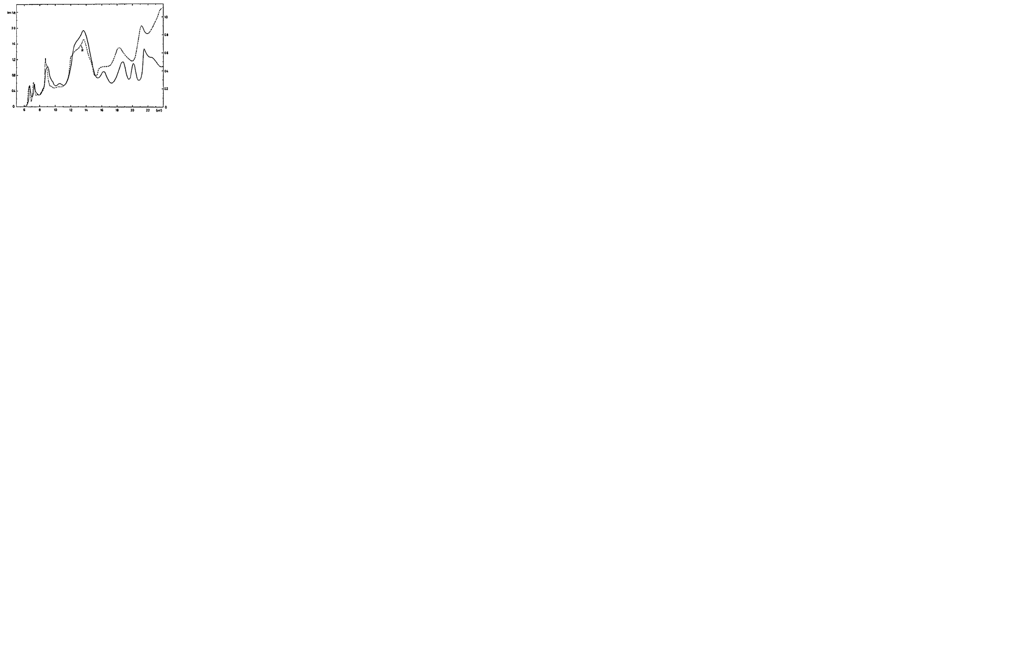

Fig.4. Energy-loss function of KBr from energy-lossmeasurements( full line) compared with optical data(dashed line). Peaks below 10 eV are due to exciton states; the13–14 eV peak may be a plasmon resonance

**3.5. Core-electron excitation:**

The atomic electrons that are located in inner shells (labeled K, L etc from the nucleus outwards) have binding energies that are mostly hundreds or thousands of electron volts. Their excitation by a transmitted electron gives rise to *ionization edges* in the energy-loss spectrum. Since core-electron binding energies differ for each element and each type of shell, the ionization edges can be used to identify which elements are present in the specimen. They occur superimposed on a background that represents energy loss due to valence electrons (for example, the high-energy tail of a plasmon peak) or ionization edges of lower binding energy. This background contribution can be extrapolated and removed for quantitative elemental or structural analysis.

**4. EELS spectrum analysis:**

**4.1. Zero-loss peak at 0 eV:**

The first peak, the most intense for a very thin specimen, occurs at 0 eV and is therefore called the zero loss peak. It represents electrons that did not undergo inelastic scattering (interaction with the electrons of the specimen) but which might have been scattered elastically (through interaction with atomic nuclei) with an energy loss too small to measure. The width of the zero-loss peak, typically 0.2–2 eV, reflects mainly the energy distribution of the electron source. Other low-loss features arise from inelastic scattering by conduction or valence electrons.  
In thin specimens, the intensity of the zero-loss beam is high, so that damage of the CCD chip can occur. Since there is no useful information in it, the zero-loss beam is often omitted during spectrum collection.

**4.2. Low-loss region (< 50eV):**

First, dominant in materials with “weakly bound”, “quasi-free” electrons. Here, the electrons that have induced plasmon oscillations occur. Since the plasmon generation is the most frequent inelastic interaction of electron with the sample, the intensity in this region is relatively high. The peaks in this region results from a plasma resonance of the valence electrons. Intensity and number of plasmon peaks increases with specimen thickness. These low-energy loss excitations reveal electron distributions governed by solid state considerations and exhibit a response of nonlocal character to the probing charge.

**4.3. High-Loss region (> 50eV):**

For the ionization of atoms, a specific minimum energy, the critical ionization energy EC or ionization threshold, must be transferred from the incident electron to the expelled inner-shell electron, which leads to ionization edges in the spectrum at energy losses that are characteristic for an element and thus the ionization edges can be used to identify which elements are present in the specimen. Thus, EELS is complementary to X-ray spectroscopy, and it can be utilized for qualitative and quantitative element analysis as well. In particular, the detection of light elements is a main task of EELS.

Compared to the plasmon generation, the inner-shell ionization is a much less probable process, leading to a low intensity of the peaks. In the high-loss region, the amount of inelastically scattered electrons drastically decreases with increasing energy loss, thus small peaks are superimposed on a strongly decreasing background (s. spectrum).

**5. Applications:**

The EELS is one of the techniques used for material analysis in TEM. It is used along with energy diffraction and imaging. The following can be analysed with the eels technique,

**5.1. Thickness measurement:**

It is used to find local thickness (like defect or elemental concentration) of a specimen from energy loss spectrum. It is applicable to amorphous and crystalline samples. It involves recording of low loss spectrum where intensity is relatively very high.

Log ratio method is common procedure to find thickness and it is based on the measurement of the integrated intensity *I0*of a zero-loss peak relative to the integral *I*t of the whole spectrum. Poisson statistics of inelastic scattering, leads to the formula of,

*t/L* = loge*(I*t*/I*o)

Where,

L the average distance between scattering events or inelastic mean free path (MFP).

t local thickness.

To capture most of the intensity, It need only be integrated up to about 200 eV, assuming a typically thin TEM specimen (t < 200 nm). If necessary, the spectrum can be extrapolated until the spectral intensity becomes negligible. Above Equation can be rapidly implemented at each pixel of a spectrum image, yielding a semi-quantitative thickness map.

The ratio t/L provides a measure of the relative thickness of different areas of a specimen (if it has a uniform composition); knowing the absolute thickness t requires a value of the inelastic MFP for the incident-electron energy E0 and collection angle β used to record the data. If no angle limiting TEM aperture is used, lens bores limit β to a value in the range 100–200 m rad, large enough to make L a total MFP, which is tabulated for common materials at electron energies of 100 and 200 keV.

**5.2. Electronic properties of semiconductor materials:**

Eels is used for studying the properties of silicon devices having dimensions in nanoscale (it is useful to know how the band gap of a semiconductor or a dielectric changes within a device). Tem can also provide spatial resolution but eels is used because it gives energy resolution and monochromated system for band gaps of few eV’s.

The low-loss fine structure involves a joint density of states multiplied by amatrix element that differs in the case of direct and indirect transitions. Assuming no excitonic states, their analysis showed that the onset of energy-loss intensity at the bandgapenergy Eg is proportional to (E − Eg)^(1/2) for a direct gap and (E − Eg)^(3/2) for an indirect gap.

Cubic GaN is a direct-gap material whose inelasticintensity (after subtracting the zero-loss tail) fits well to(E − Eg)^(1/2) for E >Eg (Lazar et al 2003). For E >Eg ,there is some residual intensity that may be evidence of indirect transitions in a surface-oxide layer, since it can be fitted to a (E –Eg)^(3/2) function.



Fig.5: Band gaps measured by EELS (with error bars) compared with those from

optical measurement (square data points) and theoretical studies (triangles).



Fig.6. Inelastic intensity recorded from cubic GaN using a monochromated TEM-EELS system.

Above the band gap energy(Eg = 3.1 eV), data are fitted to the direct-ga expression (E − Eg)^0.5,

at lower energy to the indirect-gap expression(E − Eg)^1.5 where Eg = 2 eV.

Crystalline defects greatly affect the electrical and mechanical properties of materials, often adversely. High resolution TEM can reveal the atomic arrangement of individual defects while EELS gives information on their local electronic structure and bonding. Combining this information can lead to an understanding of how the atomic structure and physical properties are related.

**5.3. To study mechanical properties of material:**

The plasmon energy is related to mechanical properties of a material; large Ep(plasmon energy) implies a high valence-electron density, arising from short interatomic distances and/or a large number of valence electrons per atom, both of which lead to strong interatomic bonding. More specifically, the elastic, bulk and shear modulus all correlate with the square of the plasmon energy, although there is a fair amount of scatter; Mechanical properties of metal-alloy precipitates that are too small to be probed by nano indentation techniques. Ep is also correlated with surface energy, Fermi energy, polarizability (for metals) and band gap (for semiconductors).



Fig.7. Bulk modulus plotted against plasmon energy for various elements.

Silicon nano particles could provide a light-emission system that would make optoelectronics compatible with silicon-processing technology. in the figure below,he particles themselves have soft outlines, probably reflecting the delocalization of plasmon scattering but they were delineated by choosing a threshold intensity and representing the intensity contour as a mesh image. This technique made the particles more visible and showed that they have irregular shapes. Their complex morphology may explain the broad spectral range of photo and electro-luminescence observed in this material, while the large surface area of each paarticle could account for the high efficiency of light emission.



Fig.8.Tomographic reconstruction of silicon particles in silicon oxide. White ‘fog’ represents the plasmon-loss (17 eV) intensity; the silicon particles are rendered as mesh images at a constant intensity threshold.

**5.4. Elemental analysis:**

Ionization edge occurs at an energy loss that is characteristic of a particular element, EELS can be used to identify the elements present within the region of specimen defined by the electron beam. If the background to a particular edge can be extrapolated and subtracted, the remaining core-loss intensity provides a quantitative estimate of the concentration of the corresponding element, assuming the collection semi-angle β of the spectrum is known.



Fig.9.Atomic-scale elemental mapping: the 64×64-pixel images show columns of La, Ti, total and Mn atoms from (*a*)La-M, (*b*) Ti-Land (*c*) Mn-L edges recorded from La(0*.*7)Sr(0*.*3)MnO3 by spectrum imaging.

**5.5. Spatial resolution of EELS:**

The spatial resolution of an energy-loss spectrum or an energy-ﬁltered image depends on many factors. Some are instrumental and involve the electron optics of the TEM column; strongly excited lenses of small focal length (<2 mm) achieve low co-efﬁcients of spherical and chromatic aberration and a point resolution below 0.2 nm, while the aberration correction gives further improvement. However, such high performance is only meaningful when the TEM has highly stable power supplies and is operated in an environment where changes in magnetic ﬁeld, ambient pressure and temperature changes are minimized by careful room design. Other resolution factors relate to the physics of electron scattering. Elastic scattering causes a broadening of a focused electron probe, by an amount that increases with specimen thickness. Although this broadening limits the resolution of x-ray emission spectroscopy, the effective broadening is less for EELS if an angle-limiting aperture is used to eliminate electrons scattered through larger angles. Beam broadening is also less in a crystalline specimen, as a result of electron channelling down atomic columns. Although beam broadening can be minimized by using an ultrathin specimen, there is another factor that is independent of thickness and inherent to the inelastic scattering itself: delocalization of the scattering.

Delocalization can be understood in a semi-quantitative way in terms of a single- scattering model, treating beam broadening as a separate effect and regarding the delocalization distance L as a wave-optical resolution limit arising from the limited angular range of the inelastic scattering:

L50 = 0.52λ/〈θ 〉.

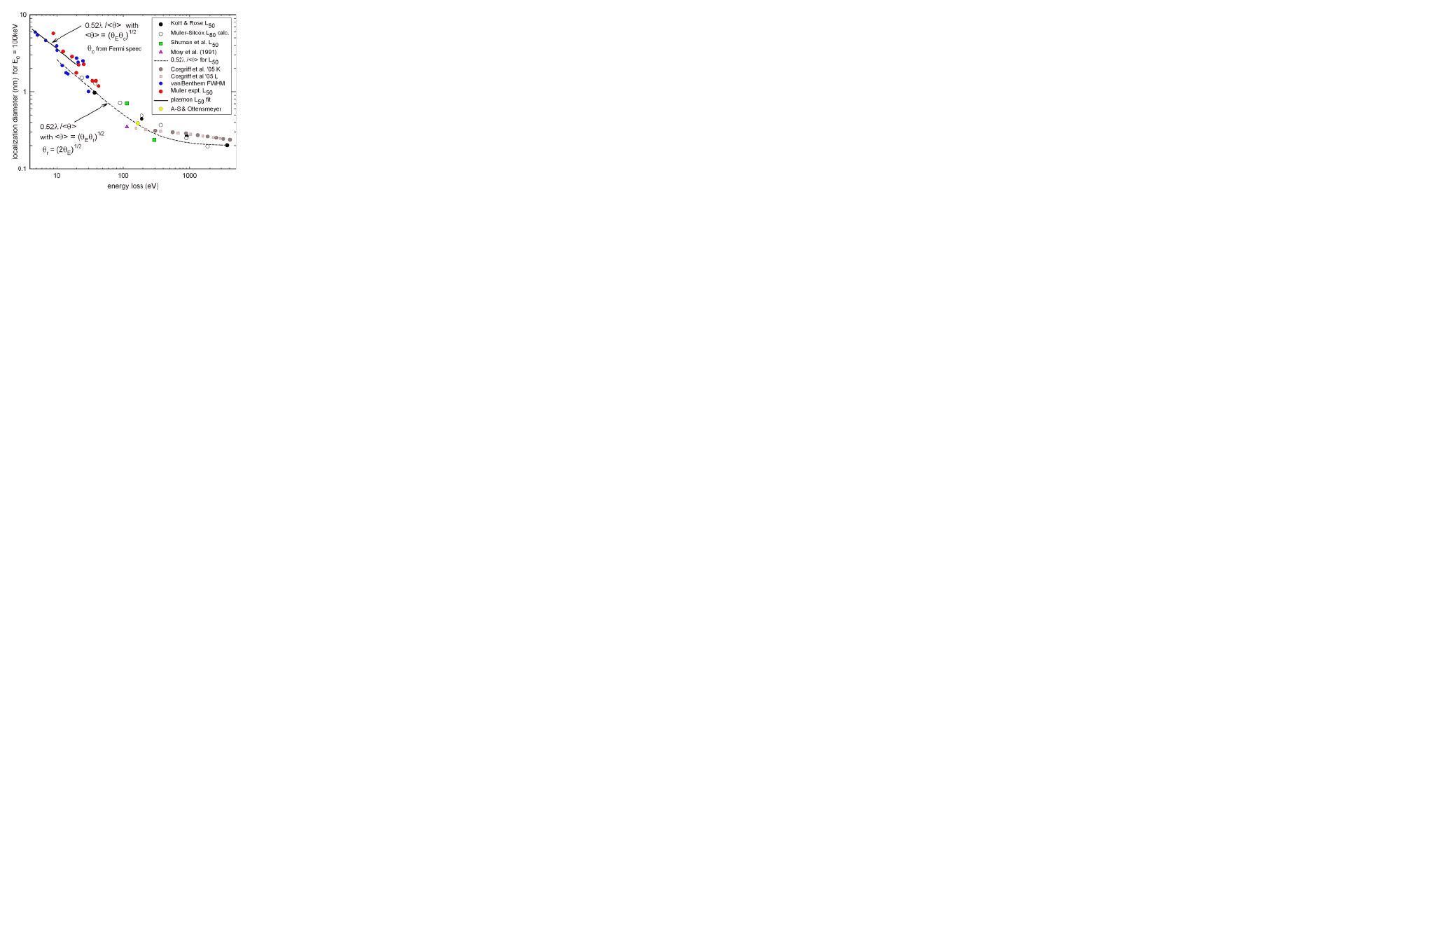The above equation is essentially the Rayleigh criterion for resolution, with the factor 0.52 chosen to reﬂect the fact that L50 is a diameter containing 50% of the inelastic scattering; λ is the transmitted-electron wavelength and 〈θ 〉 is a median angle that contains 50% of the inelastic scattering, small enough so that 〈θ〉 ≈ sin〈θ 〉 in the Rayleigh formula. For a Lorentzian angular distribution of inelastic scattering, 〈θ 〉 ≈ (θE θc )1/2 , where θc is the highest angle that reaches the electron detector.

Figure 10. Delocalization of inelastic scattering as a function ofenergy loss, for

100 keV incident energy. The dashed curve shows median scattering angle evaluated

from Bethe atomic scattering theory, solid line with 〈θ〉 based on a plasmon model

**5.6. Magnetic properties:**

The mixed dynamical form factor (MDFF) use EELS to determine magnetic (electronspin) properties of materials. This kind of measurement can be achieved using circularly polarized x-rays; but instead of using a spin-polarized electron source (whose intensity is weak), a regular TEM is used together with an energy-loss spectrometer or omega filter. The experiment involves measuring core-loss spectra at two carefully chosen locations in the diffraction plane. Under dynamical diffraction conditions, inelastic interference due to MDFF terms increases or decreases the electron intensity b several per cent (at the L3 and L2 white-line peaks of Co, Fe or Ni), dependent on the spin direction and the location of the detector in the diffraction plane. Subtraction of the two spectra then gives a signal of opposite sign at the two edges and although the signal is weak and noisy, a resolution down to 6 nm has been achieved for the L23 edges of Co.

**4.7. Radiation damage:**

In many materials, the practical limit to spatial resolution is set by radiation damage. For organic and some inorganic compounds, the damage mechanism is radiolysis (ionization damage): the breaking of chemical bonds as a result of inelastic scattering. Since this same scattering provides the EELS signal, the signal/damage ratio is independent of the accelerating voltage; damage occurs even for low- energy incident electrons, as used in HREELS, although it is conﬁned to the surface of the specimen.

X-rays, used in XAS, also cause radiolysis, although for core- loss ﬁne-structure studies the damage has been estimated to be a factor of several hundred less, depending on the width of the energy range analysed. This advantage arises because x-ray photons excite only the transitions being measured whereas electrons excite all energy losses simultaneously. X-ray damage is estimated to be a factor of 103 –104 larger than for electrons when the information being sought comes from elastic scattering (i.e. diffraction). For metallic and semi-metallic specimens, there is no radiolysis but displacement damage (due to elastic scattering) occurs at high radiation dose. This process occurs only above a threshold incident energy, which is above 200 keV for medium-Z and heavier elements. However, the displacement of surface atoms (electron-beam sputtering) has a lower energy threshold. Although the required electron dose is high, sputtering is expected to be quite rapid in a focused aberration-corrected electron probe, where the current density can exceed 106 A cm−2.

**4.8. Use of chemical shifts and near-edge fine structure:**

The oxidation state of an element can be judged from the chemical shift or from the near-edge ﬁne structure, such as the L3 /L2 ratio in the case of a transition metal. Daulton et al (2003) used techniques and plotted chromium L3 /L2 ratios and L3 threshold energy for a variety of inorganic compounds with Cr in oxidation states between 2 and 6.

As seen in ﬁgure 11, the data cluster into groups, conﬁrming a correlation between both types of measurement. They also examined Shewanella oneidensis bacteria, using an environmental cell that kept the specimen hydrated in the TEM and found that the resulting data fell into the Cr(III) region , conﬁrming that these bacteria can be active sites for reduction in the toxic Cr(VI) species in chromium-contaminated water.

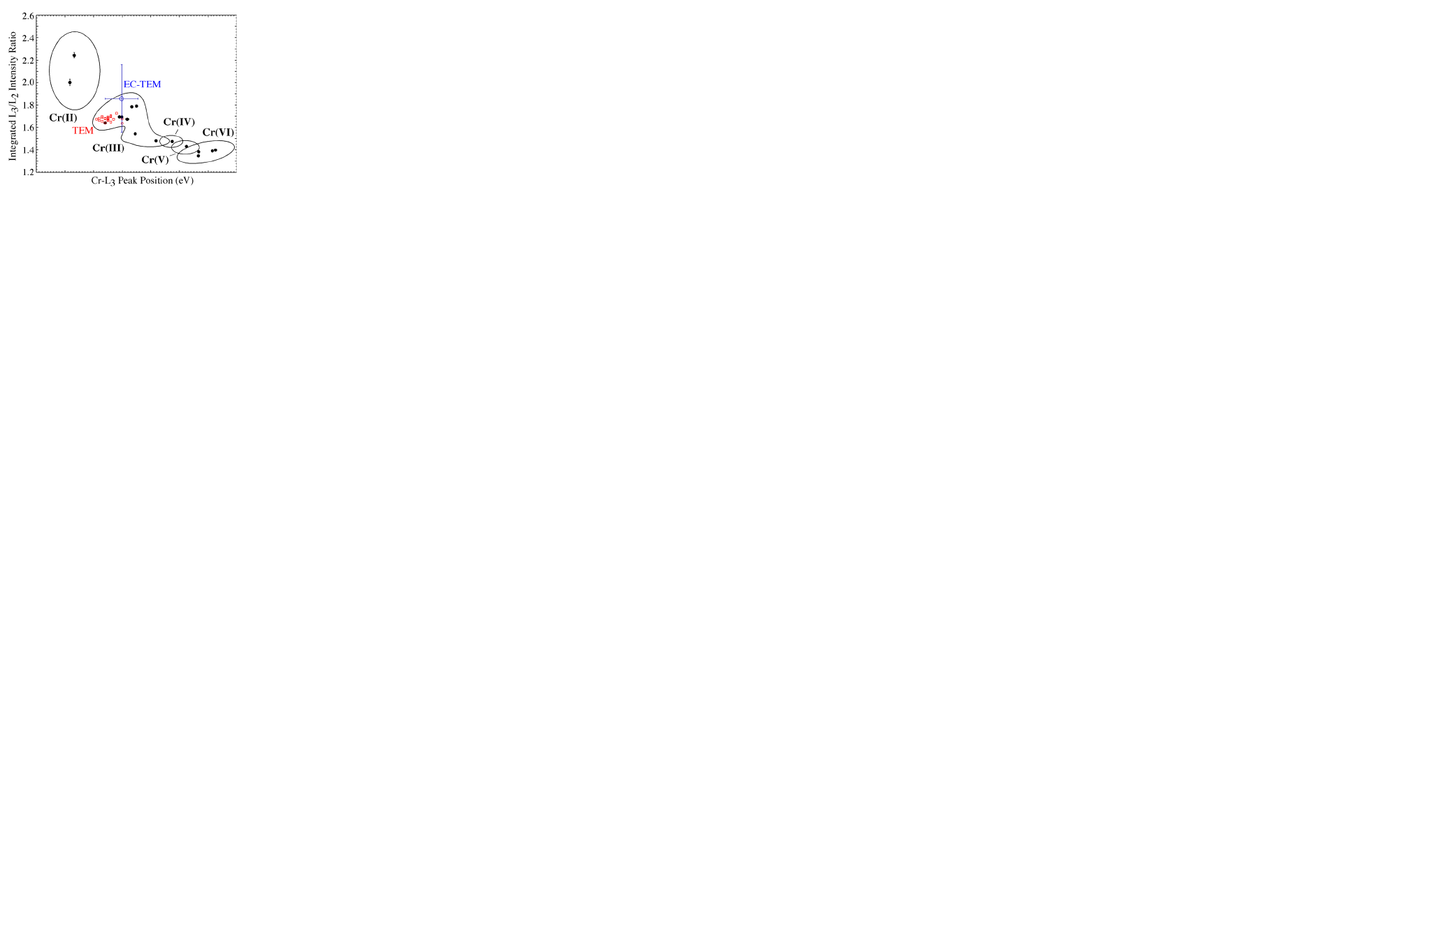

Fig.11. Chromium L3 /L2 ratio plotted against L3 threshold energy for inorganic

compounds (data points within curved boundaries) and measured for S. oneidensis

(central data point with large error bars).

Energy-ﬁltered (EFTEM) imaging has been used to plotL3 /L2 ratios as an intensity map, in order to display variations in the valence state of Mn and Co in mixed-valence specimens. The existence of a chemical shift must be considered when using core-loss spectroscopy to examine

interfaces, for example, using the ‘spatial difference’ method. As integrated circuits become increasingly miniaturized, the thickness of the gate oxide in a ﬁeld-effect transistor has fallen towards 1 nm in order to reduce gate voltage and power dissipation. Since this corresponds to only ﬁve Si atoms across, the properties of the oxide might be expected to depart considerably from the bulk values. High-resolution STEM of cross-sectional (XTEM) specimens, combined with core-loss EELS, provides a way of investigating these effects.

Fig.12. shows how the background-subtracted oxygen-K edge changes as the STEM probe approaches the Si interface from a native oxide. The threshold shifts downwards by 3 eV, indicating a reduced band gap, and the sharp threshold peak disappears. This peak arises from

backscattering of the ejected core electron from nearest- neighbour oxygen atoms (Si atoms backscatter much less than oxygen), so its absence close to the interface indicates a silicon- rich environment: a suboxide SiOx where x < 2. Similar results were obtained for thermally grown oxide, as used in device fabrication. From the analysis of the two components of the near-edge

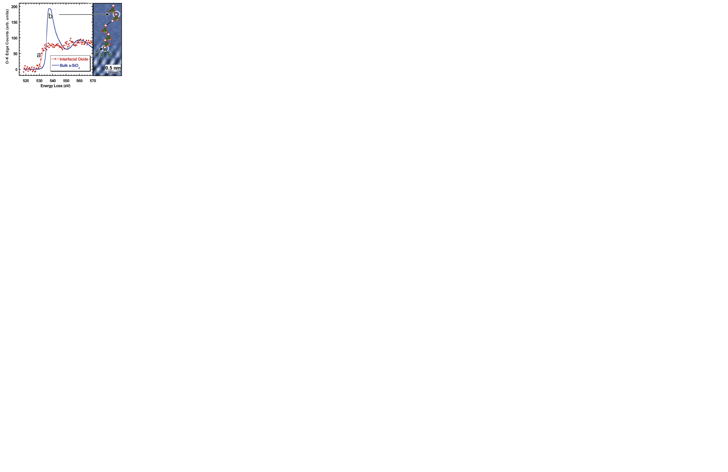

Fig.11. Oxygen K-loss spectra from the native oxide on silicon

(solid line b) and from the region near the Si interface (data a).

structure, the suboxide was estimated to have a width of 0.75 nm, out of a total thermal-oxide width of 1.6 nm. In general, the near-edge ﬁne structure can give useful information on inter atomic bonding but for quantitative results it is important to avoid edges that are strongly affected by the presence of the core hole, such as cations in ionic materials .Principal-component analysis (PCA) is a useful technique for isolating the different ﬁne-structure components present

in a spectrum-image dataset and thereby produce a map showing chemical and bonding information. Since one of the components is random noise, this technique can also reduce the image noise without sacriﬁcing spatial or energy resolution.